Alaskan Forests

Rees and Juday (2002) examined the effects of natural fires and logging by humans on the number of plant species present at different times following disturbance. Multiple sites were chosen that represented different times following burning or logging. The results are shown in the figure.

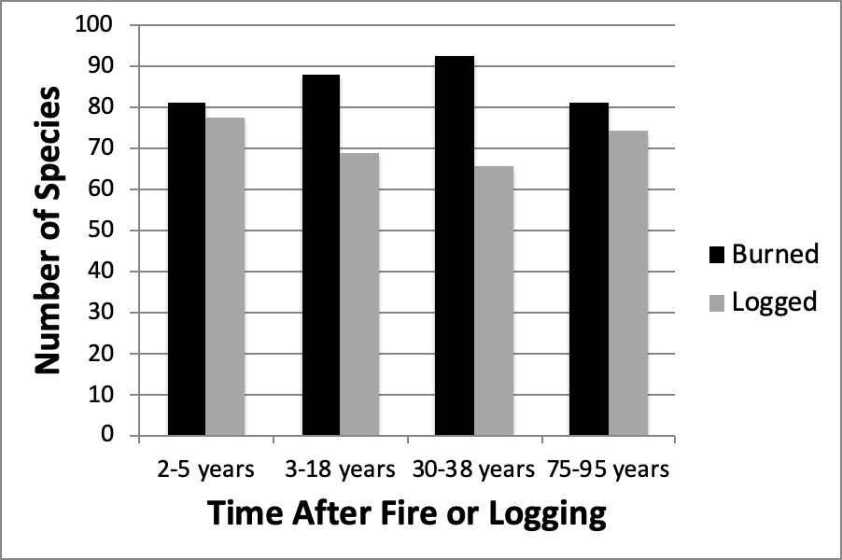

1. Fire and logging are examples of
2. The development of communities after events such as fire or logging is called:
3. Describe the results shown in the figure (pattern, numerical values, whether significant difference or not, if p-value or \* provided).
4. Describe how fire could alter resource availability for plant communities.
5. Most of the common species present 2-5 years after burning were absent in sites 75-95 years after burning. What is the most likely reason for these species being absent in older locations?
6. *Epilobium is* a small, perennial (growing year after year from an underground stem), flowering plant that is found in sites 2-3 years after fire or logging but is absent from 75- 95 year old sites. White spruce, a conifer tree 40m tall begins to dominate the 75-95 year old sites. For each statement below, circle the plant species that you would associate with each of the following characteristics?

* Allocates a large amount of resources to competition: *Epilobium* / White Spruce / Neither
* Tolerant of abiotic stress: *Epilobium* / White Spruce / Neither
* Reaches reproductive maturity quickly: *Epilobium* / White Spruce / Neither
* Long lived: *Epilobium* / White Spruce / Neither
* Produces many small, easily dispersed seeds: *Epilobium* / White Spruce / Neither
* Allocates a large amount of resources to growth: *Epilobium* / White Spruce / Neither